**Ex:4-Decision Tree Classification**

# Import necessary libraries

from sklearn.datasets import load_iris

from sklearn.model_selection import train_test_split

from sklearn.tree import DecisionTreeClassifier, plot_tree

from sklearn.metrics import accuracy_score

import matplotlib.pyplot as plt

# Load the Iris dataset

iris = load_iris()

X = iris.data # Features

y = iris.target # Labels

# Split into train and test sets (80% train, 20% test)

X_train, X_test, y_train, y_test = train_test_split(X, y, test_size=0.2, random_state=42)

# Create the Decision Tree model

clf = DecisionTreeClassifier(criterion='gini', max_depth=3, random_state=42)

# Train the model

clf.fit(X_train, y_train)

# Predict on test data

y_pred = clf.predict(X_test)

# Evaluate the model

accuracy = accuracy_score(y_test, y_pred)

print(f"Accuracy: {accuracy:.2f}")

# Visualize the decision tree

plt.figure(figsize=(12, 8))

plot_tree(clf, filled=True, feature_names=iris.feature_names, class_names=iris.target_names)

plt.title("Decision Tree on Iris Dataset")

plt.show()

**Output:**

**Accuracy: 1.00**

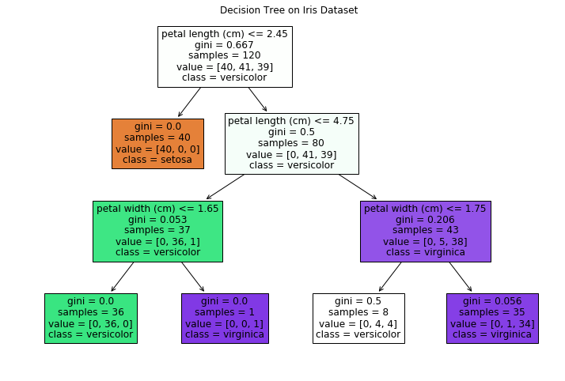

**Ex:5-Decision Tree Regression**

import numpy as np

import matplotlib.pyplot as plt

from sklearn.tree import DecisionTreeRegressor

from sklearn.model_selection import train_test_split

from sklearn.metrics import mean_squared_error, r2_score

# --- 1. Generate Sample Data ---

# For demonstration purposes, let's create some synthetic data.

# In a real-world scenario, you would load your own dataset.

np.random.seed(42) # for reproducibility

X = np.sort(5 * np.random.rand(80, 1), axis=0)

y = np.sin(X).ravel() + np.random.normal(0, 0.1, X.shape[0])

# Introduce some noise or a more complex relationship for better illustration

y[::5] += 3 * (0.5 - np.random.rand(16))

# --- 2. Split Data into Training and Testing Sets ---

X_train, X_test, y_train, y_test = train_test_split(X, y, test_size=0.2, random_state=42)

# --- 3. Create and Train the Decision Tree Regressor Model ---

# Initialize the DecisionTreeRegressor.

# Key parameters to consider:

# - max_depth: The maximum depth of the tree. Controls overfitting.

# A deeper tree can capture more complexity but might overfit.

# - min_samples_leaf: The minimum number of samples required to be at a leaf node.

# Helps prevent creating leaves with very few samples, reducing noise.

# - random_state: For reproducibility of the results.

regressor = DecisionTreeRegressor(max_depth=5, random_state=42)

# Train the model using the training data

regressor.fit(X_train, y_train)

# --- 4. Make Predictions ---

y_pred_train = regressor.predict(X_train)

y_pred_test = regressor.predict(X_test)

# To visualize the full range of the model's predictions,

# let's create a finer grid of X values

X_grid = np.arange(min(X), max(X), 0.01)[:, np.newaxis]

y_grid_pred = regressor.predict(X_grid)

# --- 5. Evaluate the Model ---

# Mean Squared Error (MSE): Average of the squared differences between predicted and actual values.

mse_train = mean_squared_error(y_train, y_pred_train)

mse_test = mean_squared_error(y_test, y_pred_test)

# R-squared (R2) Score: Represents the proportion of variance in the dependent variable

# that can be predicted from the independent variable(s). Closer to 1 is better.

r2_train = r2_score(y_train, y_pred_train)

r2_test = r2_score(y_test, y_pred_test)

print(f"--- Model Evaluation ---")

print(f"Training MSE: {mse_train:.4f}")

print(f"Testing MSE: {mse_test:.4f}")

print(f"Training R-squared: {r2_train:.4f}")

print(f"Testing R-squared: {r2_test:.4f}")

# --- 6. Visualize the Results ---

plt.figure(figsize=(10, 6))

plt.scatter(X_train, y_train, s=20, edgecolor="black", c="darkorange", label="Training data")

plt.scatter(X_test, y_test, s=20, edgecolor="black", c="cornflowerblue", label="Testing data")

plt.plot(X_grid, y_grid_pred, color="red", linestyle='--', linewidth=2, label="Decision Tree Prediction")

plt.xlabel("Features (X)")

plt.ylabel("Target (y)")

plt.title("Decision Tree Regression")

plt.legend()

plt.show()

# --- Optional: Visualize the Tree Structure (requires graphviz and pydotplus) ---

# If you have graphviz installed and pydotplus:

# from sklearn.tree import export_graphviz

# import graphviz

#

# dot_data = export_graphviz(regressor, out_file=None,

# feature_names=["Feature_X"],

# filled=True, rounded=True,

# special_characters=True)

# graph = graphviz.Source(dot_data)

# graph.render("decision_tree_regression") # This will save a PDF file of the tree

# graph # To display in a Jupyter Notebook/IPython environment

**Output:**

--- Model Evaluation ---

Training MSE: 0.0212

Testing MSE: 0.4227

Training R-squared: 0.9659

Testing R-squared: 0.5573

